Intermolecular Forces Notes
Intermolecular forces are weak attractive forces between molecules. There are three types of intermolecular forces. The first one is called dispersion forces, the second one is dipole-dipole interaction and finally, the third one is Hydrogen forces. Dispersion forces are the weakest whereas the Hydrogen forces is the strongest intermolecular force.

Dispersion Forces:
- This is the type of intermolecular forces which exists between all molecules. It is the weakest intermolecular force.
- Other names of London dispersion forces: Van der Waals forces, instantaneous-instantaneous dipole forces, dispersion forces.

How do Dispersion forces work?
- The theory of dispersion forces applies to all molecules. Randomly at an instant, the electrons in the atom may not be evenly distributed around the atom. Most of the electrons may go to one side, making that side partially negative, on the other side there is lack of negative charge, the nucleus is exposed more, there it becomes partially positive. This type of diploe produced is called instantaneous dipole. It is a very random process.
- The molecules next to ones with instantaneous dipole will have an induced dipole moment. Then there will be an attraction between the molecules. Sometimes these may become zero.
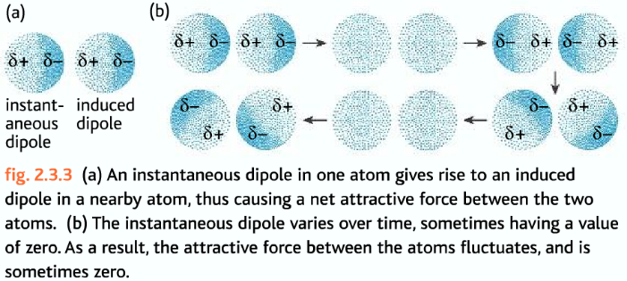
The size of this forces increases as the number of electrons in the molecule increases. More electrons mean more of this effect. More mass means more electrons, so as the mass of molecules increases the size of the Dispersion forces increases. This means the relative mass of a molecule is a guide to its relative dispersion forces. One molecule which is twice the size of the other will have relatively speaking twice the dispersion forces of the small molecule – and therefore a higher melting and boiling point.
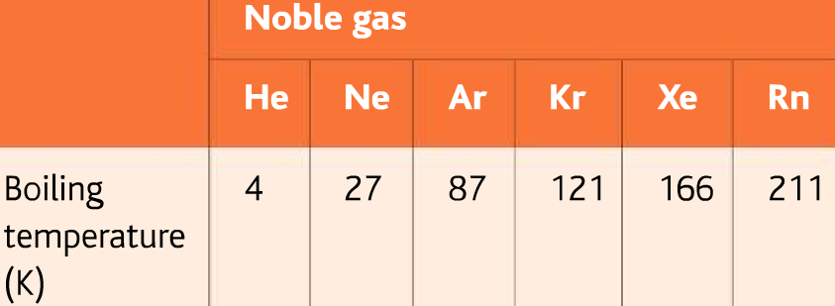
Examples of substances with only Dispersion forces present: oxygen, chlorine, fluorine, hydrogen, alkane, alkenes etc.

Dipole-Dipole Forces
- This type of interactions occurs between polar molecules
- The negative side of the molecule is attracted towards the positive side of the other molecule
- It is stronger than Dispersion forces, so molecules with Dipole-Dipole forces will have higher melting and boiling points compared to molecules of the same size without these forces.
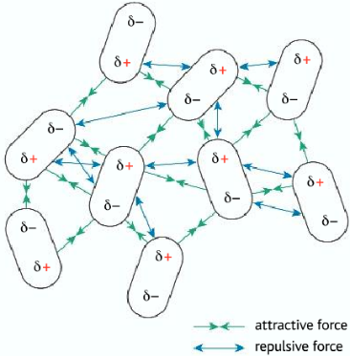
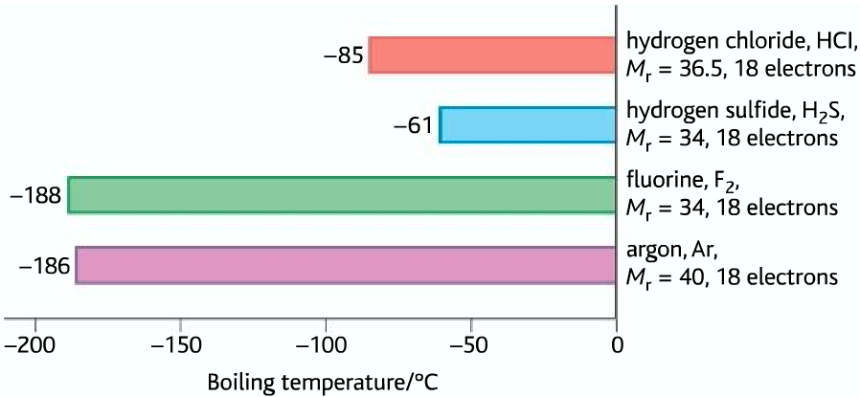
- Substances with polar molecules have both dipole-dipole interactions and dispersion forces forces.

Boiling temperature comparison

Hydrogen Forces
- Note – these intermolecular forces are generally referred to as hydrogen bonding, however to avoid the misconception they are as strong as chemical bonds I will refer to them as hydrogen forces.
- Hydrogen forces is the strongest type of intermolecular force.
- Fluorine, oxygen, and nitrogen are top three most electronegative element and Hydrogen is the least electronegative non-metal element.
- So when these three elements form covalent forces with hydrogen (0-H,H-F,H-N), the resulting bond is highly polar. Hydrogen which has only one electron, the electron density is drawn from it, leaving the positive nucleus of hydrogen exposed.
- This creates such strong dipole-dipole attractions between compounds which contain N-H, O-H, F-H bonds within them, that they are considered a special class of attractions between molecules – called Hydrogen Forces.
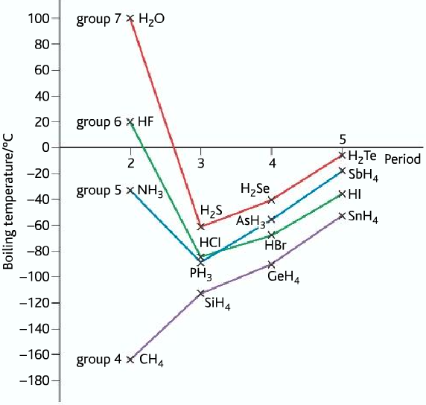
- Hydrogen forces can only be formed if O-H, H-F or N-H bonds are present.
- Common substances where hydrogen forces is formed: H₂O , HF, NH₃ , alcohol, carboxylic acid

Explaining some substances with a high boiling point
Substances like water, hydrogen fluoride and ammonia have higher boiling points than compounds with more mass, for which they are liquid at room temperature while the others are gases. This is because there is strong hydrogen forces between the molecules in these compounds, which takes a very high energy to overcome.

